**LAPORAN PRAKTIKUM SISTEM OPERASI  
MODUL 11**

**“PENJADWALAN PROSES DAN**

**MANAJEMEN MEMORI (OSSIM)”**



**Oleh:**

**NAMA : Daffa Putra Alwansyah**

**NIM : L200190031**

**KELAS : B**

**PRODI : INFORMATIKA**

**Fakultas Komunikasi dan Informatika Universitas Muhammadiyah Surakarta**

1. **FCFS**

|  |  |  |  |  |
| --- | --- | --- | --- | --- |
| Proses | Arrival Time | Burst Time | Service Time | Priority |
| P0 | 0 | 7 | 0 | 4 |
| P1 | 1 | 3 | 7 | 2 |
| P2 | 2 | 10 | 10 | 1 |
| P3 | 3 | 2 | 20 | 3 |

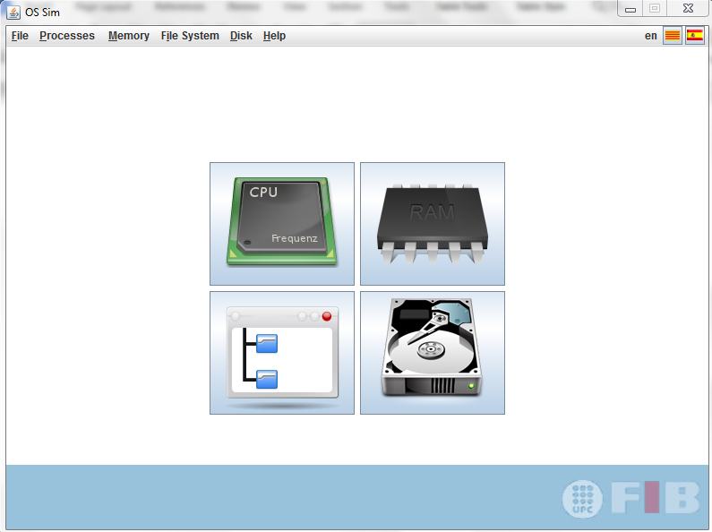  
  
  
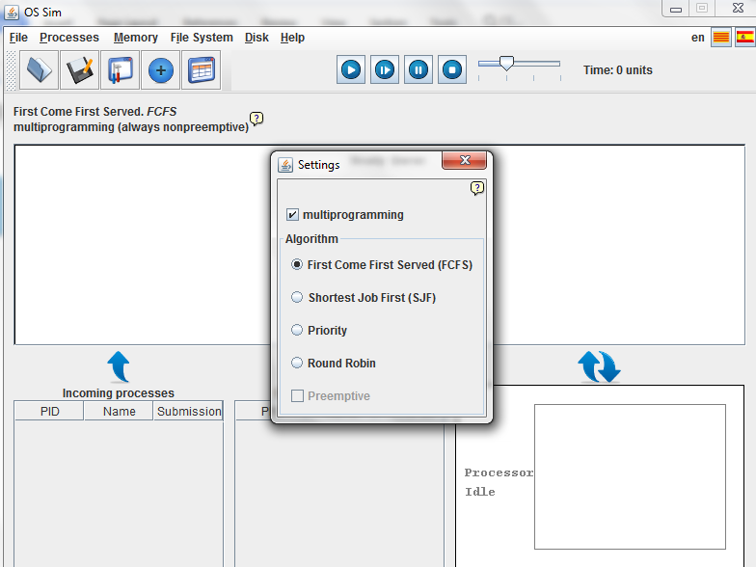  
  
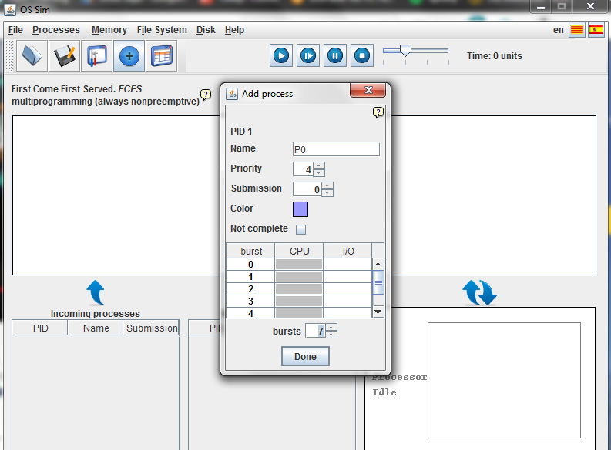  
  
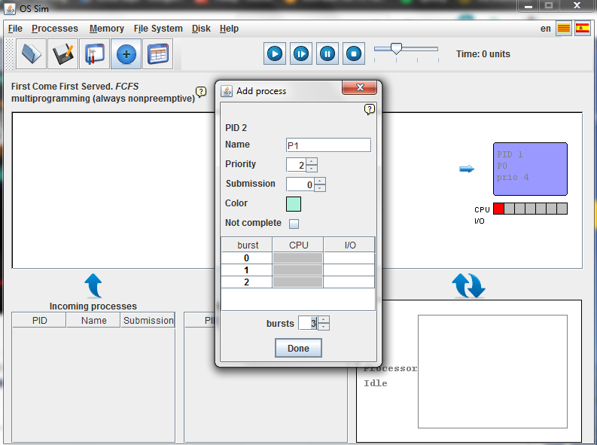  
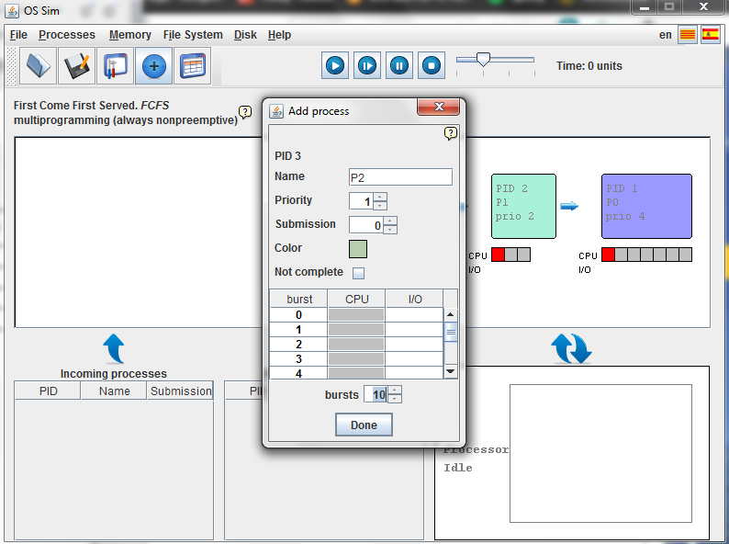  
  
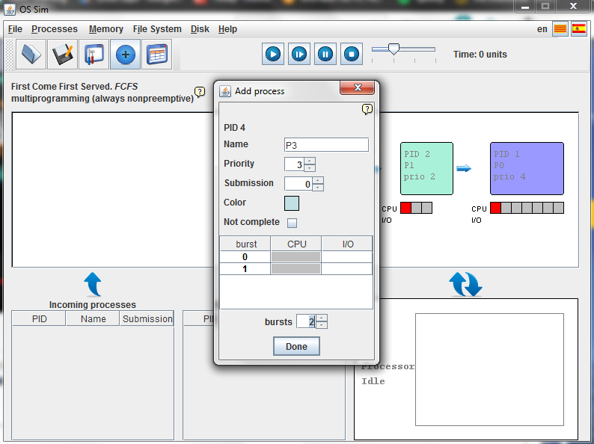  
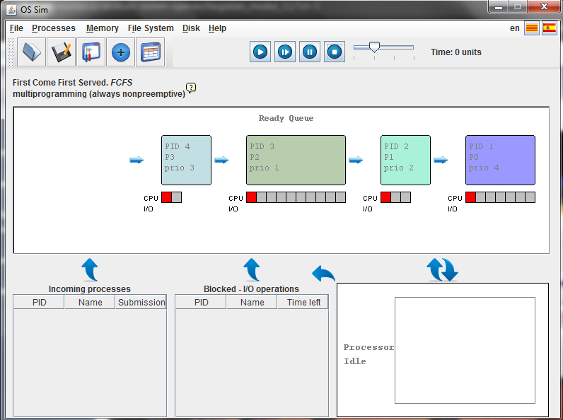  
  
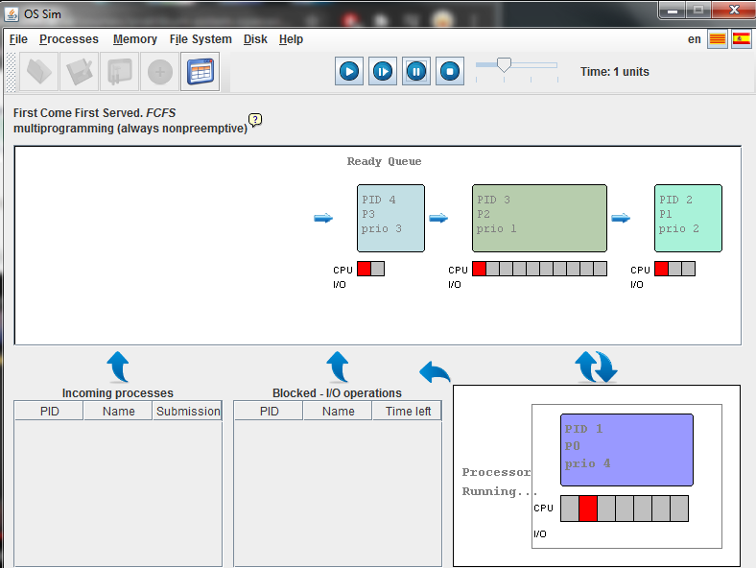  
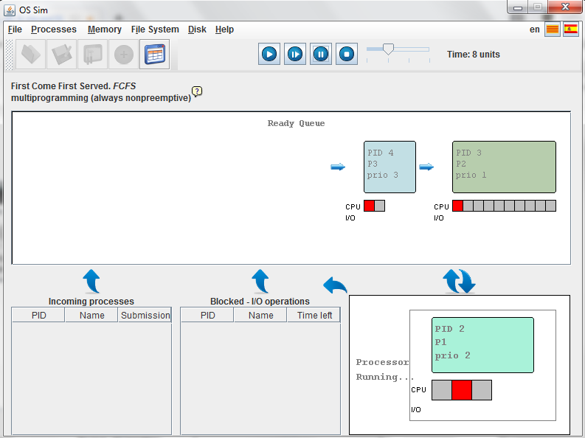  
  
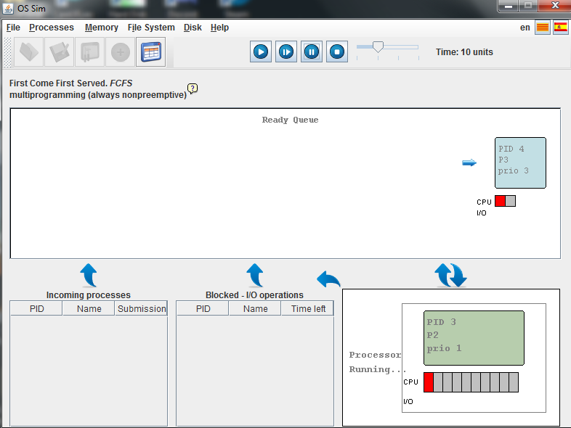  
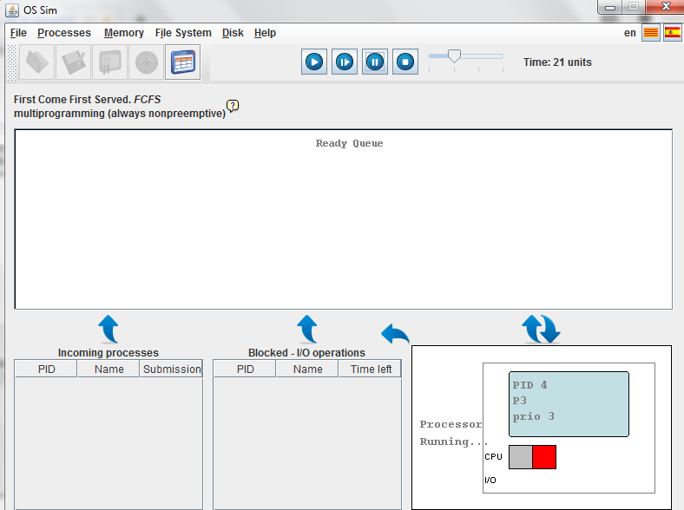  
  
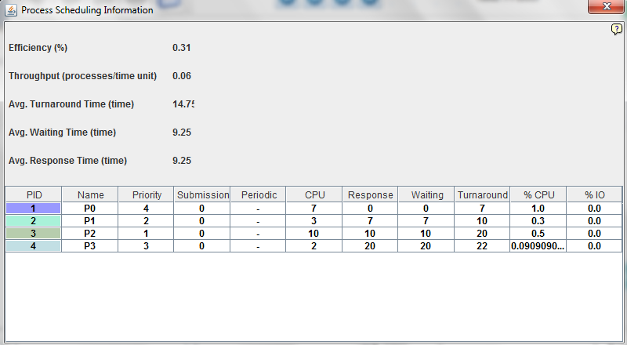

|  |  |
| --- | --- |
| **Process** | **Wait Time** |
| P0 | 0 |
| P1 | 7 |
| P2 | 10 |
| P3 | 20 |
| Avg. Waiting Time | 9.25 |
| Avg. Turnaround Time | 14.75 |
| Avg. Response Time | 9.25 |